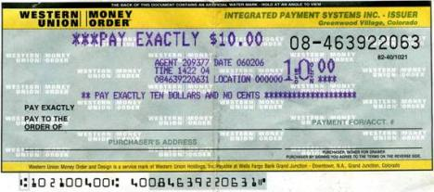
Please complete your money order as shown below.

Wynbrooke ASEDP Week of service
Child’s Name/grade Your signature
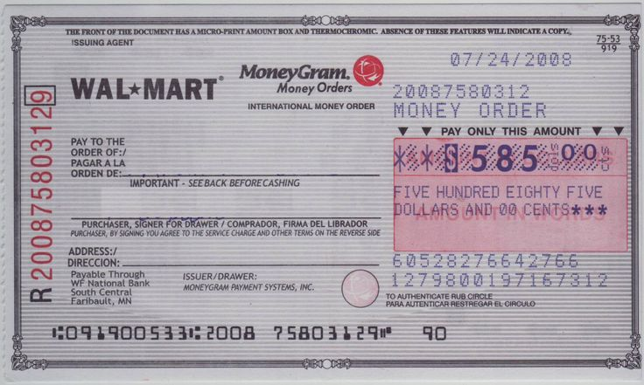

Wynbrooke ASEDP
Your signature
Childs’s name/grade
Week of service

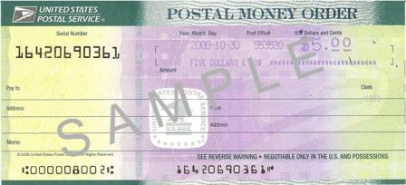

Wynbrooke ASEDP
Childs’s name/grade Week of service

All payments must list the following:
Pay to the order of: Wynbrooke ASEDP
Week of Service: 8/8-8/12
Name/grade of student: Jane Doe/5th
Your Signature (if applicable) : Jennifer Doe

